// Filereader

import java.io.FileReader;

class Read {
public static void main(String args[]) {
char[] array = new char[100];
try {
FileReader input = new FileReader("input.txt"); // Creates a reader
input.read(array); // reads
System.out.println("Here is the Data in the file : ");
System.out.println(array);
input.close(); // closes
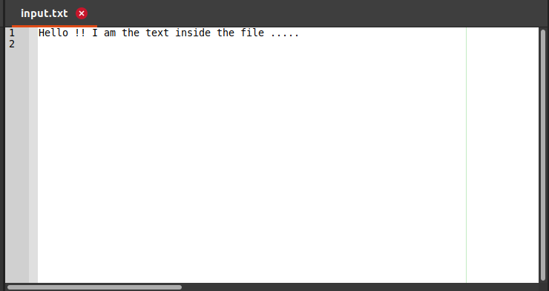
}
catch(Exception e) {
e.getStackTrace();
}
}
}

Output :

